DWH – DataWithBaraa
What is DWH?
- A subject-oriented, integrated, time-variant, and non-volatile collection of data in support of management’s decision-making process
  - subject-oriented: means DWH focus on the business area, such as sales, customers, finance
  - integrated: because it integrates multiple source systems, usually build the warehouse not only for one system, but for multiple sources
  - time-variant: you can keep historical data inside the DWH
  - non-volatile: means once the data entered to the DWH, it is not deleted or modified
What is ETL?
- ETL stands form extract, transform, and load
- it is a process that you do in order to extract the data from the sources, and then apply multiple transformation and load the data into the target system, such as a data warehouse
  - Extract: get data from one or more source systems
  - Transform: clean and change the data, so it suitable for analysis
  - Load: load the transformed data into the target system
ETL Methods
- Extract
  - Extraction Methods
    - push extraction
    - pull extraction
  - Extract Type
    - full extraction
    - incremental extraction
  - manual techniques
    - manual database extraction
    - database querying
    - file parsing
    - APIs calls
    - event based streaming
    - CDC
    - web scrapping
- Transform
  - data enrichment
  - data integration
  - derived columns
  - data aggregations
  - business rules & logic
  - data normalization & standardization
  - data cleansing
    - remove duplicates
    - data filtering
    - handling missing data
    - handling invalid values
    - handling unwanted spaces
    - data type casting
    - outlier detection
- Load
  - processing type
    - batch processing
    - stream processing
  - load methods
    - full load
      - truncate & insert
      - upsert
      - drop, create, insert
    - incremental load
      - upsert
      - append
      - merge
  - slowly changing dimensions (SCD)
    - SCD 0 – no historization
    - SCD 1 – overwrite
    - SCD 2 – historization

Project Requirements
Building the data warehouse (Data Engineering)
- objective
  - develop a modern data warehouse using SQL Server to consolidate sales data, enabling analytical reporting and informed decision-making
- specifications
  - data sources: import data from two source systems (ERP and CRM) provided by CSV files
  - data quality: cleanse and resolve data quality issues prior to analysis
  - integration: combine both sources into a single, user-friendly data model designed for analytics queries
  - scope: focus on the latest dataset only; histroization of data is not required
  - documentation: provide clear documentation of the data model to support both business stakeholders and analytics teams
What is Data Architecture?
- Means the overall design of how data moves from source systems to the data warehouse and eventually to users/BI tools
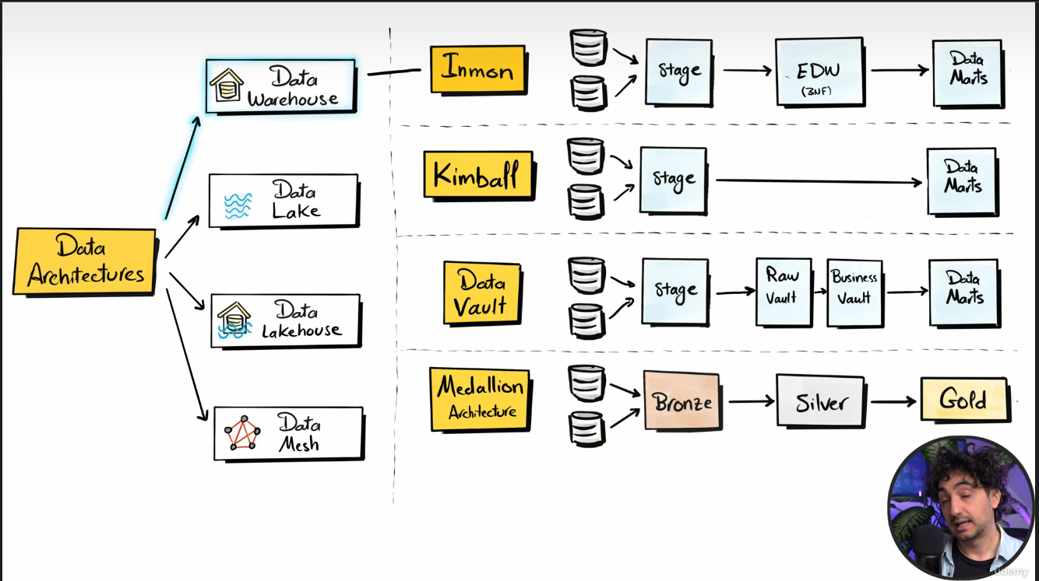

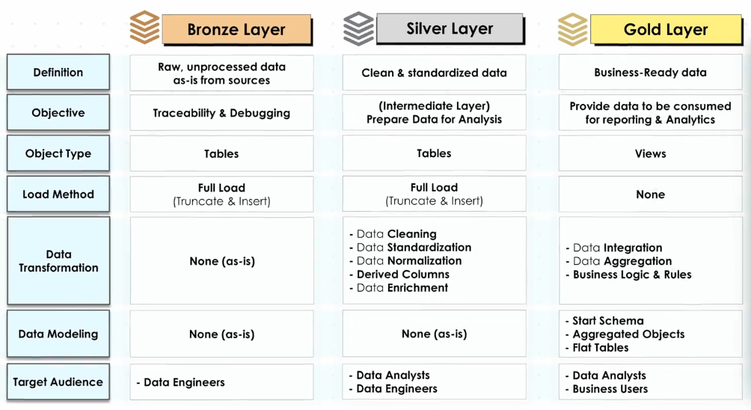
Design Data Warehouse Layers
Draw DWH Architecture
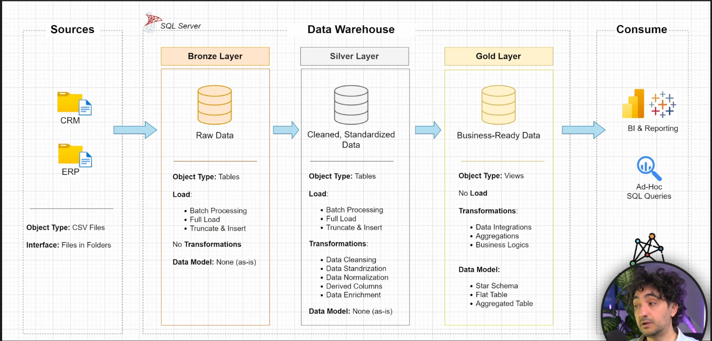
Naming Conventions
- snake_case
- camelCase
- kebab-case
- PascalCase [first word for all words capital]
Table Naming Conventions
- Bronze Rule: all names must start with the source system name, and table names must match their original names without remaining
- Silver Rule: all names start with the source system name, and table names must match their original names without remaining
- Gold Layer: all names must use meaningful, business-aligned names for tables, starting with the category prefix
Build The Bronze Layer
- the first thing before coding is analyzing, understand the source system
- then coding [data ingestion]
- then start with data validation [data completeness & schema checks]
- finally, documentations and versions [versioning in GIT]
Business Context & Ownership
- who owns the data?
  - Identifies the responsible department/team
- What business process it supports?
  - Customer transactions, supply chain, finance, …
- system and data documentation
  - understand how the source system works and what the data represents
- Data Model & Data Catalog
  - understand tables, relationships, columns, data types, keys, and business definitions
Architecture & Technology Stack
- how is data stored?
  - SQL Server, Oracle, AWS, Azure
- once we understand how the data is stored, then we can discuss what are the integration capabilities (API, Kafka, File Extract, Direct DB, ...)
How To Extract the Data from Source Systems and Load It into the Data Warehouse
- discuss how to load the data [incremental load | full load]
- discuss the data scope & historical needs
- what is the expected size of the extracts?
- Are there any data volume limitations?
- How to avoid impacting to the source system’s performance?
- Authentication and authorization [tokens, SSH keys, VPN, IP whitelisting, ...]
Load Scripts
- Using Bulk insert is a method of loading massive amounts of data very quickly from files like CSV files, or maybe text file directly into a database
-- ============================================================
-- Load CRM Customer Data into Bronze Layer
-- ============================================================

-- Determine which database to connect to
USE DataWarehouse;
GO

-- First truncate the table to avoid duplicates
TRUNCATE TABLE bronze.crm_cust_info;
GO

-- Then insert the data
BULK INSERT bronze.crm_cust_info
FROM 'D:\Data\crm_cust_info.csv'
WITH (
FORMAT = 'CSV',
FIRSTROW = 2,
FIELDQUOTE = '"',
FIELDTERMINATOR = ',',
ROWTERMINATOR = '0x0a',
TABLOCK
);
GO

-- Verify the loaded data
SELECT *
FROM bronze.crm_cust_info;
GO

-- Verify row count
SELECT COUNT(*) AS RowCount
FROM bronze.crm_cust_info;
GO
Build Stored Procedure
CREATE OR ALTER PROCEDURE bronze.load_bronze AS
BEGIN

-- Calculate the time needed to load each table
DECLARE @start_time DATETIME, @end_time DATETIME;

BEGIN TRY

PRINT '=============================';
PRINT 'Loading Bronze Layer';
PRINT '=============================';

PRINT '-----------------------------';
PRINT 'Loading CRM Tables';
PRINT '-----------------------------';

-- ==========================================================
-- Load CRM Customer Information
-- ==========================================================

SET @start_time = GETDATE();

PRINT '>> Truncating Table: bronze.crm_cust_info';
TRUNCATE TABLE bronze.crm_cust_info;

PRINT 'Inserting Data into Table: bronze.crm_cust_info';
BULK INSERT bronze.crm_cust_info
FROM 'D:\02 projects\06 DataWarehouseProject\Datasets\source_crm\cust_info.csv'
WITH (
FORMAT = 'CSV',
FIRSTROW = 2,
FIELDQUOTE = '"',
FIELDTERMINATOR = ',',
ROWTERMINATOR = '0x0a',
TABLOCK
);

SET @end_time = GETDATE();

PRINT '>> Loading Duration: '
+ CAST(DATEDIFF(MILLISECOND, @start_time, @end_time) AS NVARCHAR)
+ ' Milliseconds';
PRINT '>> --------------------------------';

-- ==========================================================
-- Load CRM Product Information
-- ==========================================================

SET @start_time = GETDATE();

PRINT '>> Truncating Table: bronze.crm_prd_info';
TRUNCATE TABLE bronze.crm_prd_info;

PRINT 'Inserting Data into Table: bronze.crm_prd_info';
BULK INSERT bronze.crm_prd_info
FROM 'D:\02 projects\06 DataWarehouseProject\Datasets\source_crm\prd_info.csv'
WITH (
FORMAT = 'CSV',
FIRSTROW = 2,
FIELDQUOTE = '"',
FIELDTERMINATOR = ',',
ROWTERMINATOR = '0x0a',
TABLOCK
);

SET @end_time = GETDATE();

PRINT '>> Loading Duration: '
+ CAST(DATEDIFF(MILLISECOND, @start_time, @end_time) AS NVARCHAR)
+ ' Milliseconds';
PRINT '>> --------------------------------';

-- ==========================================================
-- Load CRM Sales Details
-- ==========================================================

SET @start_time = GETDATE();

PRINT '>> Truncating Table: bronze.crm_sales_details';
TRUNCATE TABLE bronze.crm_sales_details;

PRINT 'Inserting Data into Table: bronze.crm_sales_details';
BULK INSERT bronze.crm_sales_details
FROM 'D:\02 projects\06 DataWarehouseProject\Datasets\source_crm\sales_details.csv'
WITH (
FORMAT = 'CSV',
FIRSTROW = 2,
FIELDQUOTE = '"',
FIELDTERMINATOR = ',',
ROWTERMINATOR = '0x0a',
TABLOCK
);

SET @end_time = GETDATE();

PRINT '>> Loading Duration: '
+ CAST(DATEDIFF(MILLISECOND, @start_time, @end_time) AS NVARCHAR)
+ ' Milliseconds';
PRINT '>> --------------------------------';

PRINT '-----------------------------';
PRINT 'Loading ERP Tables';
PRINT '-----------------------------';

-- ==========================================================
-- Load ERP Customer Information
-- ==========================================================

SET @start_time = GETDATE();

PRINT '>> Truncating Table: bronze.erp_cust_az12';
TRUNCATE TABLE bronze.erp_cust_az12;

PRINT 'Inserting Data into Table: bronze.erp_cust_az12';
BULK INSERT bronze.erp_cust_az12
FROM 'D:\02 projects\06 DataWarehouseProject\Datasets\source_erp\CUST_AZ12.csv'
WITH (
FORMAT = 'CSV',
FIRSTROW = 2,
FIELDQUOTE = '"',
FIELDTERMINATOR = ',',
ROWTERMINATOR = '0x0a',
TABLOCK
);

SET @end_time = GETDATE();

PRINT '>> Loading Duration: '
+ CAST(DATEDIFF(MILLISECOND, @start_time, @end_time) AS NVARCHAR)
+ ' Milliseconds';
PRINT '>> --------------------------------';

-- ==========================================================
-- Load ERP Location Information
-- ==========================================================

SET @start_time = GETDATE();

PRINT '>> Truncating Table: bronze.erp_loc_a101';
TRUNCATE TABLE bronze.erp_loc_a101;

PRINT 'Inserting Data into Table: bronze.erp_loc_a101';
BULK INSERT bronze.erp_loc_a101
FROM 'D:\02 projects\06 DataWarehouseProject\Datasets\source_erp\LOC_A101.csv'
WITH (
FORMAT = 'CSV',
FIRSTROW = 2,
FIELDQUOTE = '"',
FIELDTERMINATOR = ',',
ROWTERMINATOR = '0x0a',
TABLOCK
);

SET @end_time = GETDATE();

PRINT '>> Loading Duration: '
+ CAST(DATEDIFF(MILLISECOND, @start_time, @end_time) AS NVARCHAR)
+ ' Milliseconds';
PRINT '>> --------------------------------';

-- ==========================================================
-- Load ERP Product Category Information
-- ==========================================================

SET @start_time = GETDATE();

PRINT '>> Truncating Table: bronze.erp_px_cat_g1v2';
TRUNCATE TABLE bronze.erp_px_cat_g1v2;

PRINT 'Inserting Data into Table: bronze.erp_px_cat_g1v2';
BULK INSERT bronze.erp_px_cat_g1v2
FROM 'D:\02 projects\06 DataWarehouseProject\Datasets\source_erp\PX_CAT_G1V2.csv'
WITH (
FORMAT = 'CSV',
FIRSTROW = 2,
FIELDQUOTE = '"',
FIELDTERMINATOR = ',',
ROWTERMINATOR = '0x0a',
TABLOCK
);

SET @end_time = GETDATE();

PRINT '>> Loading Duration: '
+ CAST(DATEDIFF(MILLISECOND, @start_time, @end_time) AS NVARCHAR)
+ ' Milliseconds';
PRINT '>> --------------------------------';

-- ==========================================================
-- End of Procedure
-- ==========================================================

PRINT '=======================================';
PRINT 'Bronze Layer Loaded Successfully';
PRINT '=======================================';

END TRY

BEGIN CATCH

PRINT '==================================================';
PRINT 'Error Occurred During Loading Bronze Layer';
PRINT 'Error Message: ' + ERROR_MESSAGE();
PRINT 'Error Number: ' + CAST(ERROR_NUMBER() AS NVARCHAR);
PRINT 'Error State: ' + CAST(ERROR_STATE() AS NVARCHAR);
PRINT '==================================================';

END CATCH

END;
GO

EXEC bronze.load_bronze;

Build The Silver Layer
- Analyzing: explore & understand the data
- Coding: data cleansing.
  - Check the quality of bronze
  - write data transformations
  - insert into Silver
- Validating: data correctness checks
- Docs & Version
  - Data documenting, versioning in GIT

SQL files
- init_database.sql
- DDL.sql
- load_scripts.sql

